EXPERIMENTNO12
Determinationandplottingofmagneticandelectricfieldintensity duetoinfinitelongconductoratanyspecificpointlocatedatH

Aim:
TowriteprogramforMagneticfieldintensityofinfinitelong conductor using SCILAB.

Softwarerequired:
- SCILABversion6.0.1

Program:
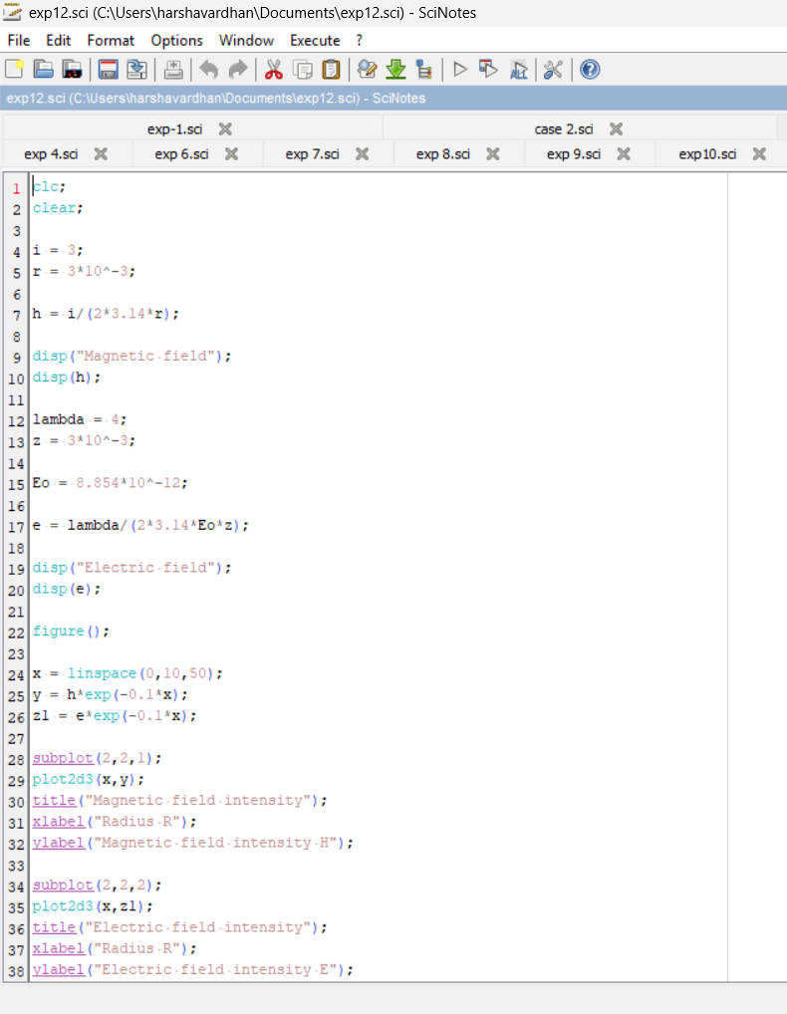

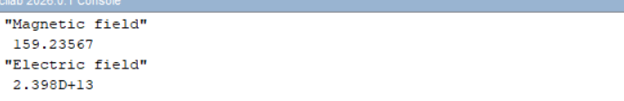

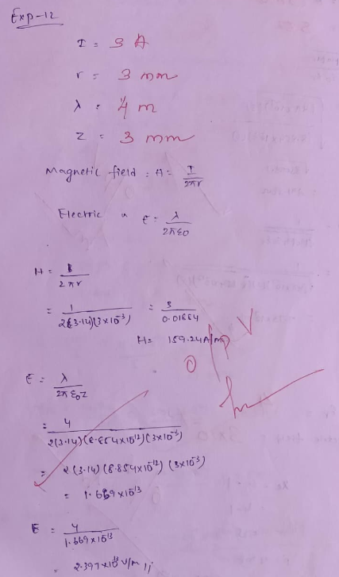

Case1:Toexaminehowthemagneticandelectricfieldintensities changewithvaryingdistancesfroman infinitelylongcurrent-carrying conductor.

Program:
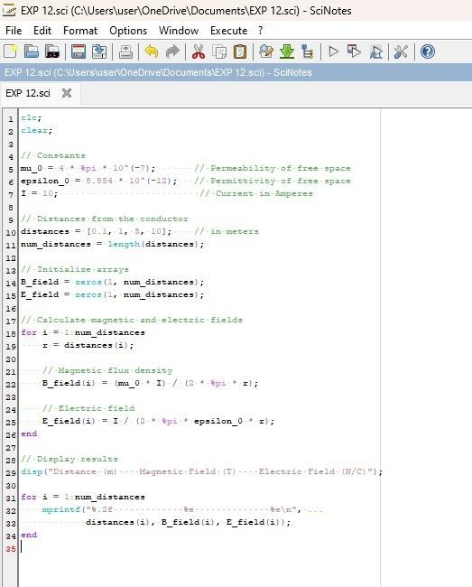

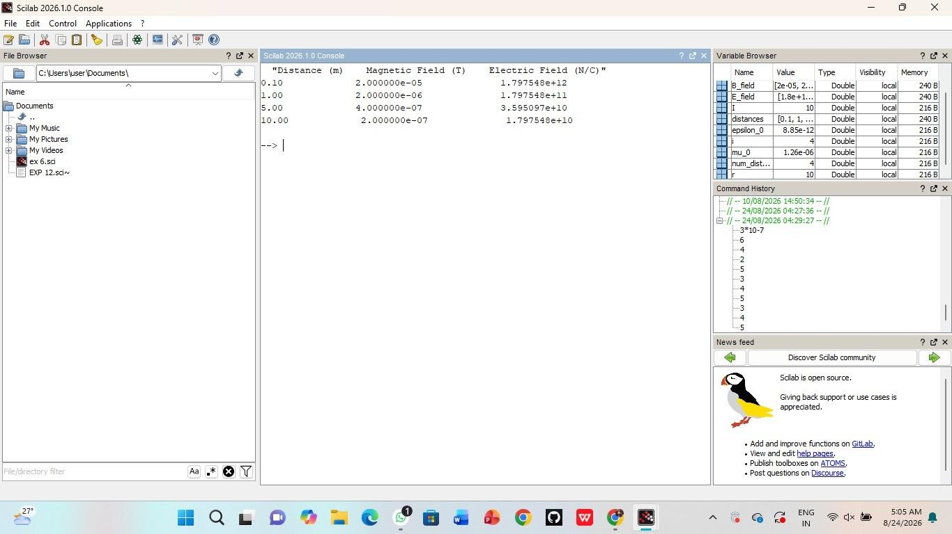
Case 2:To study how the magnetic and electric field intensities changeforaninfinitelylongconductoratafixeddistanceHbutwith varyingcurrents.

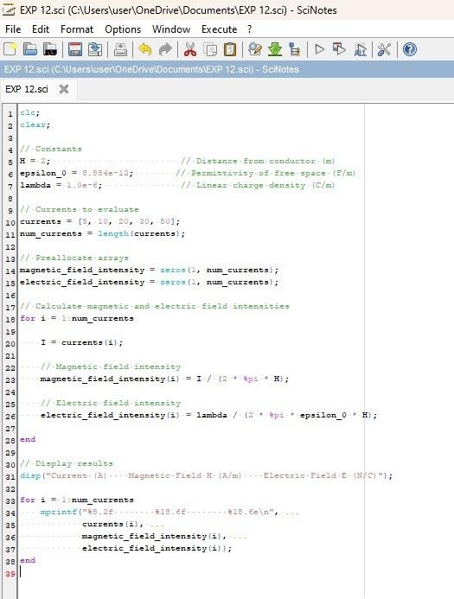

Output:
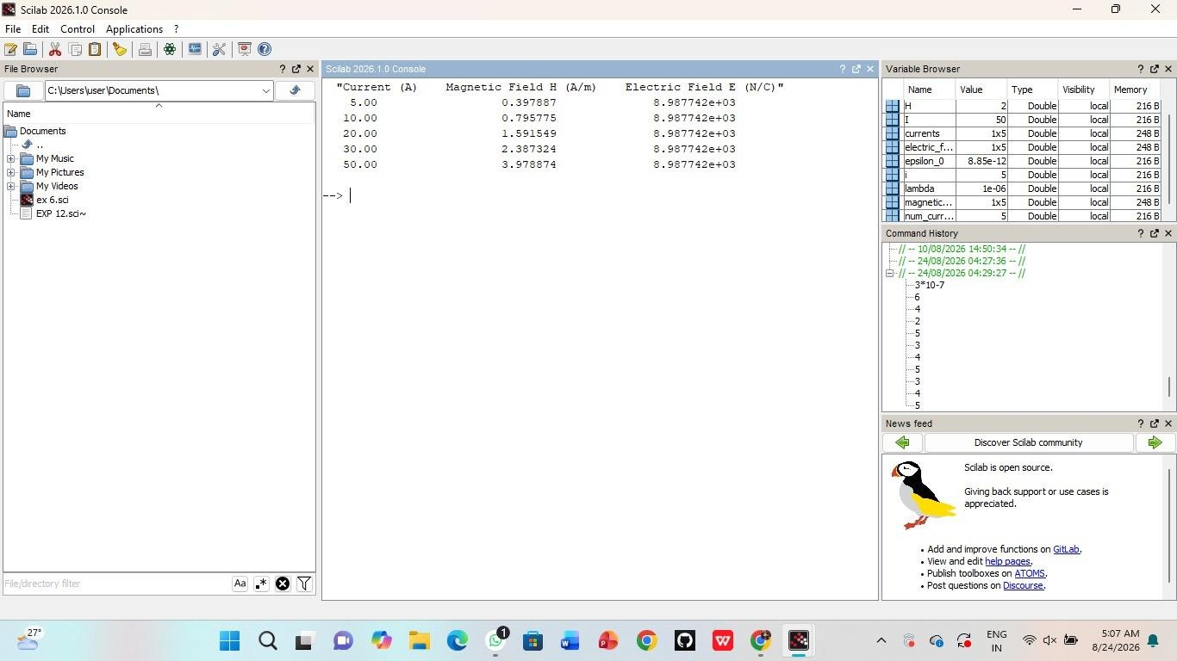
Case3:Toanalyzethemagneticandelectricfieldintensitiesdueto an infinitely long conductor when there is a potential difference (voltage)acrosstheconductor,simulatingacapacitiveeffect.

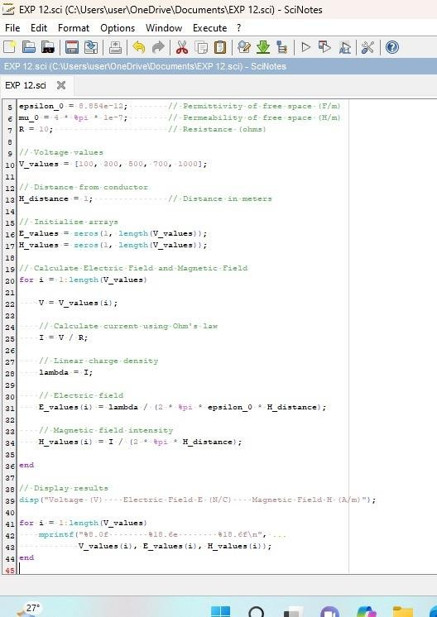

Output:
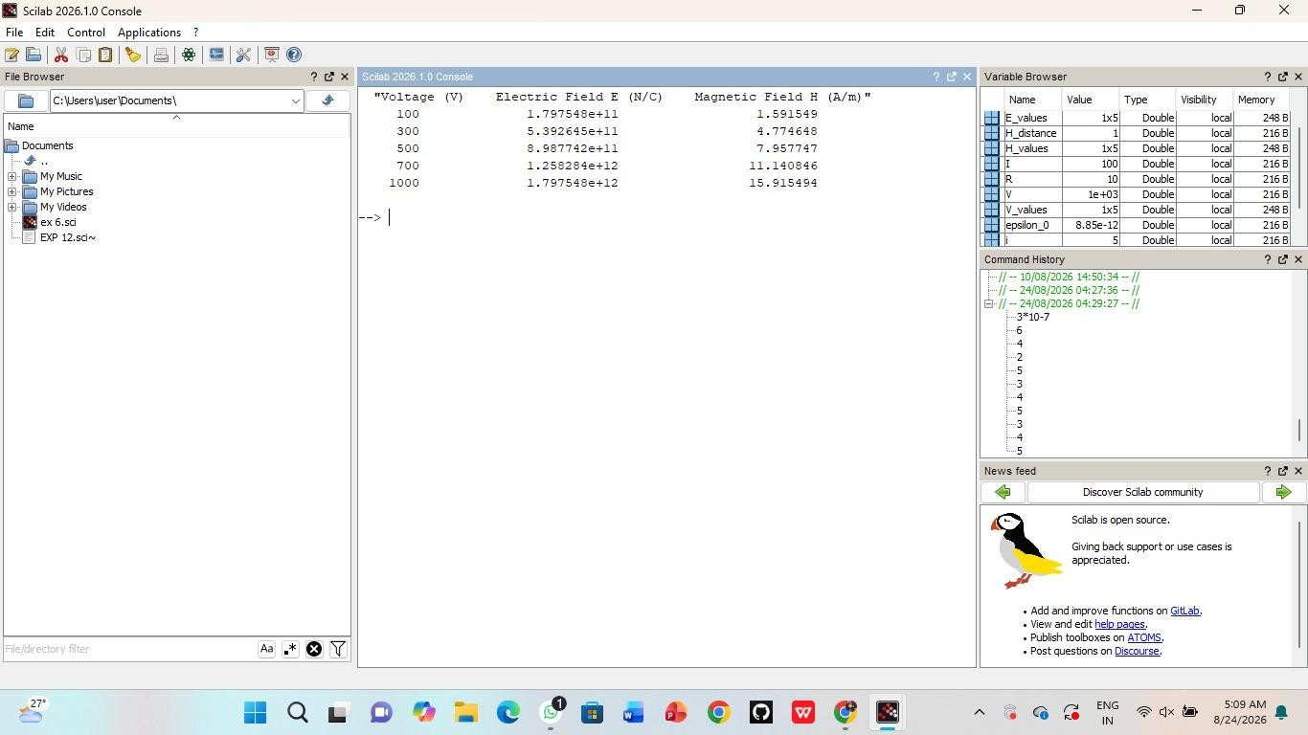
Result:Thustheprogramwasverifiedforthemagneticandelectric fieldintensitiesduetoinfinitelylongconductor.

